AUGUST
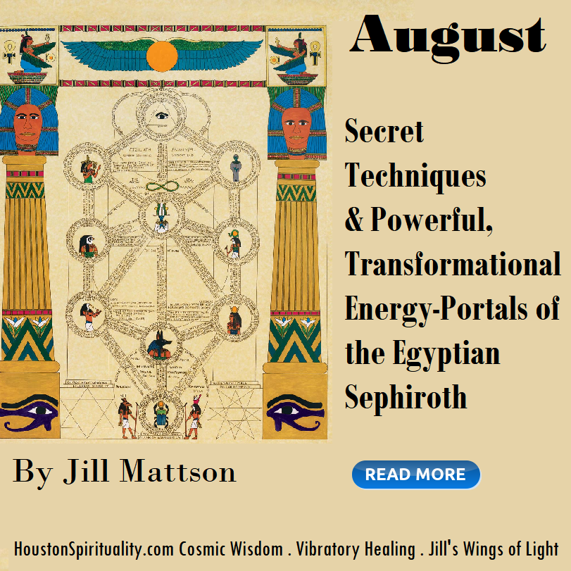
Secret Techniques & Powerful, Transformational Energy-Portals of the Egyptian Sephiroth

By Jill Mattson

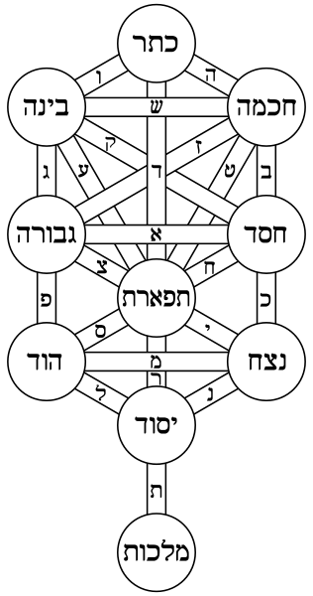

The secrets of the prized Tree of Life in the Kabbalah tradition originates deep with the ancient Egyptian Temple Traditions.
Both secret traditions regard each circle, called a Sephiroth, in the Tree of Life Blueprint - as a portal of higher dimensional energy. Legends have it that God, or All that Is, descended into matter to experience life at the human level, stepping down or compartmentalizing energies, each subset becoming denser and a small pocket of energy.
“As above, so below”. Humans experience a small shadow of this high divine energy. The typical experience as a human being reflects these pockets of energy and consciousness. We experience similar energies as in the Higher Dimensions, but in a less powerful form and the energies in duality are malleable (often negative) … and dense versions of this Holographic, Higher Dimensional Energies.
The powerful pharaohs of Egypt believed that their Gods guarded these Higher Gateways of Powerful Uplifting Energies: the Sephiroth. These High Energy Streams were locked and prevented from flowing to human beings. The keys to these incredibly important gateways were never thrown away. They were hidden, in plain sight, carved - time and time again - in indelible stone! People left “a breadcrumb trail” to find our way home – to all consciousness and awareness – with abundant streams of powerful connected energies! On this interview with Darius at You Wealth Revolution and Jill Mattson, experience some of the Sephiroth Sound Attunements! Unlock the gates to these Higher Dimensional Energies!
How did Higher Energies of God stop flowing from us?
Higher Beings that created these “locks” are thinner in substance (think of an elf or faery godmother) than humans are. If these Higher Beings locked up something precious, it would be silly to guard it with a steel lock that we use today, as Higher Beings can slip right into what is impenetrable to us. How would Higher Evolved Beings keep subtle and quantum energies blocked? Sound, colors, lights and shapes would tangle energies, like creating huge knots in infinitesimal strings… in our modern String Theory. On this interview with Darius at You Wealth Revolution, and Jill Mattson on April on April 2 at 4:00 est, experience the Sephiroth Sound Attunements!

Sound Codes – the Sephiroth Attunements
Ancient Sound Codes were carved in stone for us to utilize!
Most ancient texts were musical scripts that were sung for easy memorization of them. The Bibal group, many distinguished scholars, interpret old texts such as the Old Testament and other ancient scripts and recreate music and deeper/hidden meanings from them. The numbers, letters, dots and dashes had musical, numerical and symbolic meanings.
Ancient languages were all considered to be a subdivision of All That Is or God’s energies. Most religious traditions credit creation with sound and the spoken word. Letters and words were believed to be audible versions of other energies, not part of symbolic communication. To understand their way of thinking, recall cymatics, in which one can see the sacred sound of OM create the shape in loose sand that is used to denote OM in the ancient Hindu tradition. The sound and the symbol were different octaves of the same energies. The Sepiroth are depicted with the letters of the ancient Hebrew languages, and are thumbprints of the actual Higher Divine Energies. Further, the entire set of letters in the ancient Hebrew languages represent the gamut of God’s Creational Energies.
Pythagoras was quotes as saying, “All is Number!” Just what does that mean? Everything is energy. Energy vibrates. The pace of pulsations of energies can be counted and we call them frequencies. Think that String Theory is correct. All is number, expressed as vibrating strings (frequencies) or our world or other dimensions. The Sephiroth are numbered from 1 to 10, and are considered archetypes, that is each one is an experience or consciousness that is known to all of humanity.
The Sephiroth Energies are the building blocks of the Higher Blueprint of Divine Energies!
What are Blueprints of Energies? Imagine being in a gym where jocks think “good” is how fast you run and yet in another group “good” is getting an A on an exam. When in the presence of other like-minded people, similar thoughts combine and create waves: delta, alpha, beta or theta brain wave patterns. These waves ripple into the environment and it becomes difficult to think differently than others in a like-minded group. They create a “wave pool” and if you don’t march to your own drummer, you fall in line with the group’s way of understanding the world. In a similar way, each Sephiroth has its own energy, one that we experience in a dense and less powerful form. Yet, when we look at the symbols of the Sephiroth, we sync with the energy version of the High Dimensional Powerful Sephiroth. It is powerful & divine medicine!
In ancient traditions, the High Powerful God Energies contained in the Sephiroth, were set apart so that humanity could experience density, duality and life as a human. However, humans always long for the divine and sweet remembrance of higher energies. Ancient disciples stared at each symbol (see each picture of Sephiroth) to experience resonance with the Higher powerful streams of transforming energies.
The super energies within the Sephiroth were to be experienced with visual mediation, rather than intellectually understanding them.
The method of converting the Sephiroth’s shapes to frequencies and harmonic patterns was the deepest ancient secret, but now these methods are returned to us as we journey back to the divine. You can listen to the carefully crafted sounds designed to unlock the High Dimensional Energies hiding behind each Sephiroth. Receive a powerful dosage with each listen and visual meditation. Sound, being the most powerful subtle energy dosage possible, enables us to propel our energies into powerful realms, quickly.
Listening to these sound codes activates these higher dormant energies within. The tonal patterns are sometimes called the Resurrection Frequencies, or the Sephiroth Attunements.
Some descriptions of these High and Powerful versions of archetypical energies have been handed down throughout the ages.
Keter Sepiroth - Wisdom, Male, Will, Selflessness
Binah Sepiroth - Wisdom, Understanding, Female, Emotions, Stable, Organizes, Intellect, Reasoning
Gevurah Sepiroth - Justice, Severity, Strength, Judgement, Intention, Awe of God, Power Courage
Chesed Sepiroth - Mercy, Kindness, Loving Grace, What is the Da’at?
Hod Sepiroth - Splendor, Surrender, Sincerity, Controls Practical & Emotional with Mental Powers, Intellect that is flexible, Balance Thoughts & Feelings
Hekhmah Sepiroth - Intelligence, Male Will, Selflessness
Malkuht Sepiroth - Female Vessel, Physical Expression of the Divine, Kingdom, Physical World, Self-Expression
Netzach Sepiroth - Beauty, Symmetry, Balance, Balances Hesod and Gevurah, Compassion, Sacrifice, Sincerity, Being True to yourself, Coordinates, Harmony, Equilibrium
Teferet Sepiroth - Beauty, Symmetry, Balance, Balances Hesod and Gevurah, Compassion, Sacrifice, Sincerity, Being True to yourself, Coordinates, Harmony, Equilibrium
Yesod Sepiroth - Foundation, Middle of the Road, Accomplish, Coherent Knowledge
Malkut Sephiroth - Kingdom, the physical expression of the Divine, Self-Expression, the Bride (and the groom is Keter)

Secret Techniques & Powerful, Transformational
Energy-Portals of the Egyptian Sephiroths

The secrets of the prized Tree of Life in the Kabbalah tradition originates deep with the ancient Egyptian Temple Traditions.
Both secret traditions regard each circle, called a Sephiroth, in the Tree of Life Blueprint - as a portal of higher dimensional energy. Legends have it that God, or All that Is, descended into matter to experience life at the human level, stepping down or compartmentalizing energies, each subset becoming denser and a small pocket of energy.
“As above, so below”. Humans experience a small shadow of this high divine energy. The typical experience of a human being reflects these pockets of energy and consciousness. We experience similar energies as in the Higher Dimensions, but in a less powerful form and the energies in duality are malleable (often negative) … dense versions of this Holographic, Higher Dimensional Energies.
The powerful pharaohs of Egypt believed that their Gods guarded these Higher Gateways of Powerful Uplifting Energies: the Sephiroth. These High Energy Streams were locked and prevented from flowing to human beings. The keys to these incredibly important gateways were never thrown away. They were hidden, in plain sight, carved - time and time again - in indelible stone! Ancient priests left “a breadcrumb trail” to find our way home – to ALL consciousness and awareness – with abundant streams of powerful energies! In this interview with Darius at You Wealth Revolution and Jill Mattson, experience some of the Sephiroth Sound Attunements! Unlock the gates to these Higher Dimensional Energies!
Higher Beings that created these “locks” are thinner in substance (think of an elf or faery godmother) than humans are. If these Higher Beings locked up something precious, it would be silly to guard it with a steel lock that we use today, as Higher Beings can slip right into what is impenetrable to us. How would Higher-Evolved-Beings keep quantum energies blocked? Sound, colors, lights and shapes would tangle subtle energies, like creating huge knots in infinitesimal strings…(think to our modern String Theory). On this interview with Darius at You Wealth Revolution, and Jill Mattson on April on April 2 at 4:00 EST, experience the Sephiroth Sound Attunements! Feel & ingest the streams of higher consciousness!
Sound Codes – the Sephiroth Attunements
Most ancient texts were musical scripts that were sung for easy memorization of them. The Bibal group, many distinguished scholars, interpret old texts, such as the Old Testament and other ancient scripts, and recreate music and deeper/hidden meanings from them. The numbers, letters, dots and dashes have musical, numerical and symbolic meanings.
Ancient languages were all considered to be a subdivision of All That Is or God’s energies. Most religious traditions credit creation with sound and the spoken word. Letters and words were believed to be audible versions of other energies, not part of symbolic communication. To understand their way of thinking, recall cymatics, in which one can see the sacred sound of OM create the shape in loose sand that is used to denote OM in the ancient Hindu tradition. The sound and the symbol were different octaves of the same energies. The Sepiroth are depicted with the letters of the ancient Hebrew languages, and are thumbprints of the actual Higher Divine Energies. Further, the entire set of letters in the ancient Hebrew languages represent the gamut of God’s Creational Energies.
Pythagoras was quotes as saying, “All is Number!” Just what does that mean? Everything is energy. Energy vibrates. The pace of pulsations of energies can be counted and we call them frequencies. Think that String Theory is correct. All is number, expressed as vibrating strings (frequencies) or our world or other dimensions. The Sephiroth are numbered from 1 to 10, and are considered archetypes, that is each one is an experience or consciousness that is known to all of humanity. The Sephiroth Energies are the building blocks of the Higher Blueprint of Divine Energies!
What are Blueprints of Energies? Imagine being in a gym where jocks think “good” is how fast you run and yet in another group “good” is getting an A on an exam. When in the presence of other like-minded people, similar thoughts combine and create waves: delta, alpha, beta or theta brain wave patterns. These waves ripple into the environment and it becomes difficult to think differently than others in a like-minded group. They create a “wave pool” and if you don’t march to your own drummer, you fall in line with the group’s way of understanding the world. In a similar way, each Sephiroth has its own energy, one that we experience in a dense and less powerful form. Yet, when we look at the symbols of the Sephiroth, we sync with the energy version of the High Dimensional Powerful Sephiroth. It is powerful & divine medicine!
In ancient traditions, the High Powerful God Energies contained in the Sephiroth, were set apart so that humanity could experience density, duality and life as a human. However, humans always long for the divine and sweet remembrance of higher energies. Ancient disciples stared at each symbol (see each picture of Sephiroth) to experience resonance with the Higher powerful streams of transforming energies.
The super energies within the Sephiroth were to be experienced with visual mediation, rather than intellectually understanding them.
The method of converting the Sephiroth’s shapes to frequencies and harmonic patterns was the deepest ancient secret, but now these methods are returned to us as we journey back to the divine. You can listen to the carefully crafted sounds designed to unlock the High Dimensional Energies hiding behind each Sephiroth. Receive a powerful dosage with each listen and visual meditation. Sound, being the most powerful subtle energy dosage possible, enables us to propel our energies into powerful realms, quickly.

Listening to these sound codes activates these higher dormant energies within. The tonal patterns are sometimes called the Resurrection Frequencies, or the Sephiroth Attunements.
Some descriptions of these High and Powerful versions of archetypical energies have been handed down throughout the ages.
- Keter Sepiroth
- Keter is so sublime, it is called in the Zohar "the most hidden of all hidden things", and is completely incomprehensible to man. desire to come forth into the varied life of being the potential for content, it contains no content itself, and is therefore called 'Nothing', 'The Hidden Light'
- pure consciousness, beyond all categories, timeless
Binah Sepiroth
- Wisdom, Understanding, Female, Emotions, Stable, Organizes, Intellect, Reasoning
Gevurah Sepiroth
- Justice, Severity, Strength, Judgement, Intention, Awe of God, Power Courage
Chesed Sepiroth first of the emotive attributes of the sephirot. "The world rests upon three things: Torah, service to God, and bestowing kindness" (Pirkei Avot 1:2). Chesed is here the core ethical virtue.
- Mercy, Kindness, Loving Grace
- What is the Da’at?
Hod Sepiroth
- Splendor, Surrender, Sincerity, Controls Practical & Emotional with Mental Powers, Intellect that is flexible, Balance Thoughts & Feelings
Hekhmah Sepiroth
- Intelligence, Male Will, Selflessness Divine Wisdom, which existed before the world was made, revealed God
the soul with the power of intuitive insight, flashing lightning-like across consciousness the potential to be

Malkuht Sepiroth
- Female Vessel, Physical Expression of the Divine, Kingdom, Physical World, Self-Expression
Netzach Sepiroth
- Beauty, Symmetry, Balance, Balances Hesod and Gevurah, Compassion, Sacrifice, Sincerity, Being True to yourself, Coordinates, Harmony, Equilibrium
Teferet Sepiroth
- Beauty, Symmetry, Balance, Balances Hesod and Gevurah, Compassion, Sacrifice, Sincerity, Being True to yourself, Coordinates, Harmony, Equilibrium
Yesod Sepiroth
- Foundation, Middle of the Road, Accomplish, Coherent Knowledge
Malkut Sephiroth
- Kingdom, the physical expression of the Divine, Self-Expression, the Bride (and the groom is Keter)
- Ancient Egyptian "Magic" mirrors today's most perplexing scientific theory: Quantum Physics. We are rapidly approaching an Age when we will be able to confirm and understand the Egyptian mysteries and secrets. And most importantly, we will be able to use these powers to change our lives and the world around us. But why wait? Jill Mattson offers these insights today.
Most importantly, the ultimate aspiration of all the Egyptian Temples was to attain the Resurrection Frequencies, AKA the sound codes to open the corresponding ten Energy Portals (the Sephiroth) in the Tree-of-Life. Award-winning author, Jill Mattson, presents sound codes to open the most prized and hidden ancient energy streams, the Sephiroth of the Tree of Life. Experience them on the show!
